

Worksheet - 1

**Student Name:** ANIKET KUMAR **UID:**20BCS5306

**Branch:** BE-CSE **Semester:** 5th

**Subject Name:** Competitive Coding **Section/Group:** 20BCS_WM-703/B

**Objective:**

Today, we will learn about the **Array** data structure.

**Task:1**

Given an array, A of integers N, print A's elements in reverse order as a single line of space-separated numbers.

**Code:**

**#include <**bits/stdc++.h**> using namespace** std;

**void** reverse(**int** A[],**int** N){

**for**(**int** i=N-1;i>=0;i--){ cout<<A[i]<<" ";

}

}

**int** main() {

**int** N;

**int** A[1000];

cin>>N;

**for**(**int** i=0;i<N;i++){ cin>>A[i];

}

reverse(A,N);

}

**Output:**



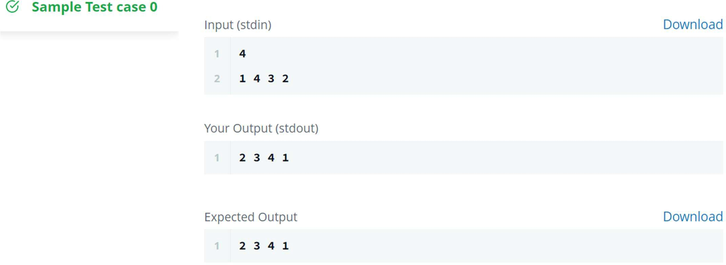

**Hacker Rank Test Case:**

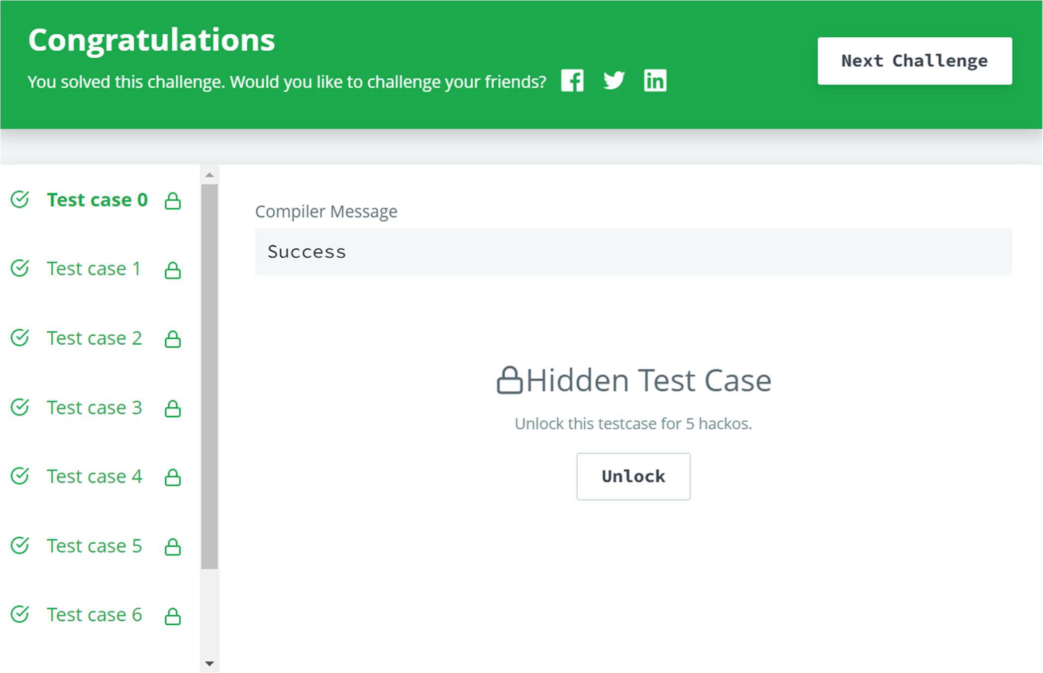



**Task:2**

Given an array of integers, find the sum of its elements.

**Code:**

**#include<**iostream**> using namespace** std;

**int** sum(**int** arr[], **int** n){

**int** sum=0;

**for**(**int** i=0;i<n;i++){ sum = sum + arr[i];

}

**return** sum;

}

**int** main() {

**int** n;

**int** arr[1000]; cin>>n;

**for**(**int** i=0; i<n; i++){ cin>>arr[i];

}

cout<<sum(arr,n)<<endl;

}

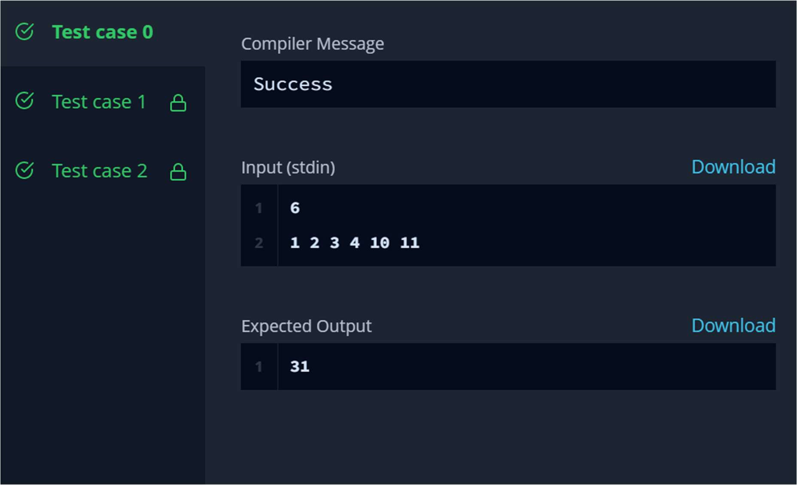

**Output:**

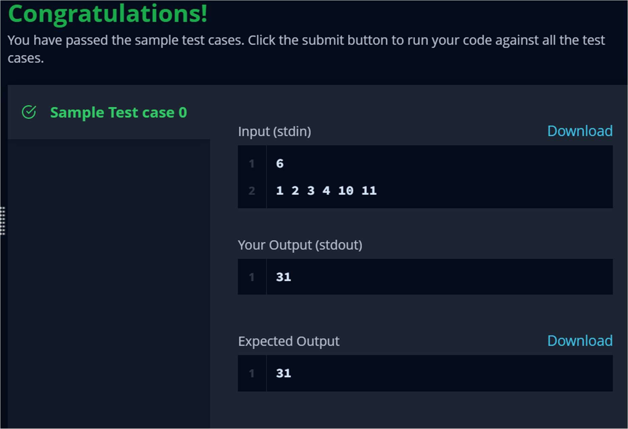

**Hacker Rank Test Case:**